

**WHO Ghana Information Note**

**WHO - IPU AFRICAN PARLIAMENTARY HIGH-LEVEL CONFERENCE ON STRENGTHENING HEALTH SECURITY PREPAREDNESS**

**ACCRA, GHANA, 08 – 10 NOVEMBER 2023**

**KEMPINSKI HOTEL, GOLD COAST CITY, ACCRA, GHANA**

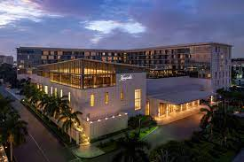



***Welcome to Accra - We are very pleased that you could join us for this conference.***

Please find below various administrative details to make your stay in Accra, Ghana more comfortable.

**GEOGRAPHY AND CLIMATE**

Accra is the capital of Ghana. Day time temperatures are between **26** to **30°C** during the month of November 2023.

**NUE OF THE MEETING**

**CONFERENCE VENUE**

The conference will be held at the Kempinski Hotel**,** Accra which is about **20 minutes** drive from **Kotoka International Airport**. Contact details for the hotel are as follows:

**Tel.:      + 233 (0) 242 436 000**

**Cell: + 233 (0) 540 123 042**

**Email:** [**reservations.accra@kempinski.com**](mailto:reservations.accra@kempinski.com)

**Prosper.anku@kempinski.com**

**HOTEL ACCOMMODATION**

Selected hotels to provide you with accommodation during your stay include:

|  |  |
| --- | --- |
| * Kempinski Hotel Gold Coast City | * Lancaster Hotel, |
| * Marriot Hotel | * Accra City Hotel |
| * Movenpick Ambassador | * Tang Palace Hotel |
| * Ibis Styles Hotel. |  |

All participants are requested to make **EARLY** and **DIRECT** reservations with the hotel of choice with [obuobieg@who.int](mailto:obuobieg@who.int); [haganc@who.int](mailto:haganc@who.int); [amipareissahm@who.int](mailto:amipareissahm@who.int); [arthursarpongs@who.int](mailto:arthursarpongs@who.int); mankampav@who.int and fahassan@who.int **in COPY** **latest by the indicated respective cut-off dates**. **Kindly inform the hotel that you’ll be attending the WHO-IPU Conference when making the reservation to qualify for the negotiated rates.** Each participant will be requested to pay for his/her accommodation directly to the hotel. ***Additional information with negotiated accommodation rates details can be found in Annex 1.***

**TRAVEL ARRANGEMENTS**

**VISA**: Participants who are nationals of **ECOWAS** countries **DO NOT** require an entry visa into Ghana. As such, those from other countries are to obtain their visas from a **Ghanaian Embassy** or **Consulate** nearest them. Similarly, UN Laissez Passer Holders **DO NOT** require an entry visa to Ghana.

Participants from countries where there are no Ghana Missions are to **send scanned copies** of their relevant **passport pages** to WHO Country Office Ghana to the Travel and Protocol Focal Point ([obuobieg@who.int](mailto:obuobieg@who.int)) with ([haganc@who.int](mailto:haganc@who.int); [amipareissahm@who.int](mailto:amipareissahm@who.int)); ([arthursarpongs@who.int](mailto:arthursarpongs@who.int)) **in COPY at least TWO WEEKS before their arrival** to facilitate the issuance of visa on arrival. Visas issued on arrival cost **USD 150.**

***NB: Visa support letter is compulsory before boarding on some flights like Asky, Ethiopian Airlines.***

**CURRENCY**

The currency of Ghana is GH¢ (Ghana cedi) in the following denominations:

**Notes**: 200, 100, 50, 20, 10, 5, 2, 1 (GH¢)

**Coins:** 50, 20, 10, 5, 1, pesewa(s)

The UN Exchange rate as of September 2023 is USD 1.00 to GH¢11.4. (UN Exchange rate for November 2023 may be slightly different). The hotels accept Visa, Master and Credit Cards as well as cash payments.

**HEALTH**

Participants should have valid vaccination certificates. For participants coming from non-endemic countries, prescribed dosages of Malaria prophylactics should be taken according to a physician’s recommendation.

Should there be the need for medical assistance, the following could be contacted through the WHO Secretariat:

**Contact numbers**

1. Euracare Hospital *–* ***Ms Anne-Rita Solano*** *+233 (0) 559 542 220*
2. Nyaho Medical Centre *-* ***Mr Francis Oppong*** *+ 233 (0) 307 086 490/ 233 (0) 501 578 793*
3. Trust Hospital *–* ***Mr Philip Beyuo*** *+233 (0) 205 888 362*
4. Ridge Hospital *–* ***Mr Sylvester Elikplim*** *+233 (0) 546 165 920*
5. 37 Military Hospital *–* **Charles Acheampong** +233 (0)244579127
6. Korle-Bu Teaching Hospital *+233 302 739510*
7. UN Clinic *–* ***Dr Abanda*** *+233 (0) 501 510 036*

*Cost for all medical treatment will be borne by participants*

**ELECTRICITY**

The electricity supply in Ghana is at 220-240 volts, 50 cycle AC. Recommended plugs are 2-pin round or 3-pin square. Please bring adapters if required.

**AIRPORT TRANSFERS**

Kempinski and the indicated hotels will be responsible for the airport transfers of all participants. A representative from each hotel will be on standby at the exit of the airport arrival hall bearing the hotel sign and the names of participants following the respective hotel reservations. Kindly share your arrival details with [haganc@who.int](mailto:haganc@who.int), [amipareissahm@who.int](mailto:amipareissahm@who.int), with copy to [arthursarpongs@who.int](mailto:arthursarpongs@who.int) and [fahassan@who.int](mailto:fahassan@who.int) for complementary pick-ups. **Also, indicate the name of the hotel where you have made room reservation when sending the arrival details.**

**PARTICIPANT REGISTRATION**

Registration of participants will take place in the lobby of the Kempinski Hotel on 08 November 2023 from **07h30**. We recommend early registration to ensure that the sessions begin on time.

**MEMORABLE SITES TO VISIT**

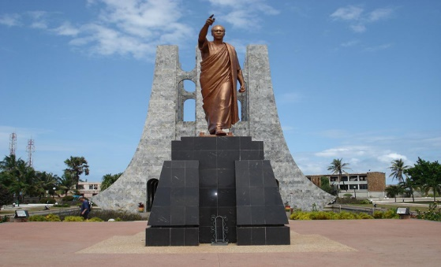 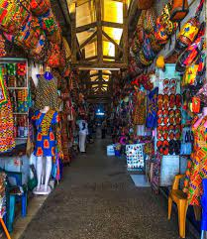

**Kwame Nkrumah Mausoleum Accra Arts Center**

**RESTAURANTS**

Please see below a number of identified restaurants with their contact details. The restaurants are not around the conference venue but reliable taxis can be arranged from the hotels. Various continental dishes and local dishes such as Banku and tilapia or okro stew, fufu with soup, ampesi with palava sauce etc are served.

* Buka Restaurant – + 233 (0) 302 782953, + 233 (0) 244 842 464
* African City Cuisine - +233 (0) 303 975 582
* Captain Hooks Restaurant - + 233 (0) 302 762 228

**USEFUL CONTACTS**

**CONTACTS IN WHO COUNTRY OFFICE –ACCRA, GHANA**

Prof Francis Kasolo, WHO Representative, [kasolof@who.int](mailto:kasolof@who.int); +233 244 342 200

Dr Argata Guyo, IPO/CPI, [guyoa@who.int](mailto:guyoa@who.int); +233 244 312 896

Mr Philip Yaro, Operations Officer, [yarop@who.int](mailto:yarop@who.int); +233 544 316 170

Mrs Cynthia Hagan, Programme Assistant, [haganc@who.int](mailto:haganc@who.int); +233 244 327 192

Mrs Matilda Amipare Issah, Programme Assistant [amipareissahm@who.int](mailto:amipareissahm@who.int); +233 544 316 016

Ms Selma Arthur-Sarpong, Programme Assistant, [arthursapongs@who.int](mailto:arthursapongs@who.int); +233 240215596

**CONTACT OF UN SECURITY OFFICER**

Mr. Christophe Ky, UNDSS Security Advisor, Accra, Ghana, Mobile:  +233 243 800 321 & +233 206 638 954; [Christophe.ky@undss.org](mailto:Christophe.ky@undss.org)

**CONTACTS IN WHO/AFRO**

Dr Dick Chamla – [chamlad@who.int](mailto:chamlad@who.int)

Dr Mary Stephen – [stephenm@who.int](mailto:stephenm@who.int)

Ms Faiza Hassan – [fahassan@who.int](mailto:fahassan@who.int)

**CONTACTS IN WHO/HQ**

Mr Ludy Prapancha- [suryantorol@who.int](mailto:suryantorol@who.int)

Ms Romina Shelter- [stelterr@who.int](mailto:stelterr@who.int)

**ANNEX 1: ACCOMODATION**

